Find Out if Gildredge Park Children’s Play Area is accessible for you

Where to find the play area
Gildredge Park is located in the Old Town area with the most accessible entrance being The Goffs, Eastbourne BN21 1HD. A bus stop is located close by to the main entrance to the park.

Where to Park
The car park is located in The Goffs, Eastbourne BN21 1HD.
You can use any of the spaces in the car park. There are also two accessible parking bays, closest to the park entrance.
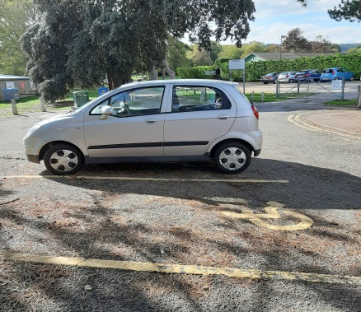

Getting from the car park to the children’s play area
To get to the play area from the accessible parking bays, you can follow a gravel path which leads to a big open grass area and the children’s play area is approximately 300 metres on the right hand side. The gravel path does not lead up to the play area.

Getting into the children’s play area
There is signage at the two accessible entrances into the play area, with the openings measuring in excess of 10000mm wide. The gates are bright yellow in colour and are opened by hand. The area is accessible to service dogs.

Getting around the children’s play area
The playground surface is accessible and made up of sunken rubber matting, wet pour as well as grass turf between. It is uneven in places due to differing surface materials.
There is a range of different play apparatus. The play space appeals to most senses, including sight, hearing, touch, providing good bright colour contrast, and a vast selection of equipment providing lots of textures, sounds and patterns.
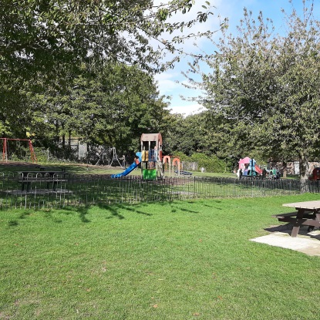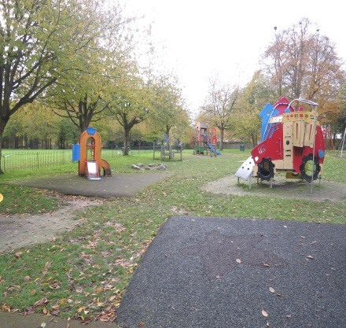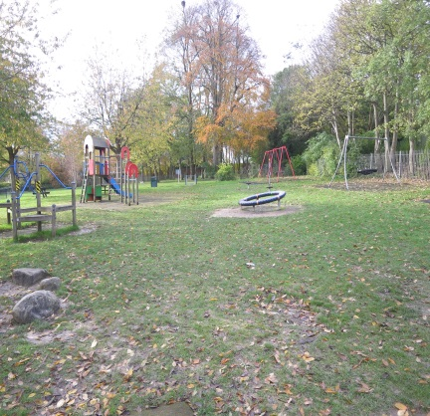

Seating
There are two picnic tables and three benches located in the play area. None of them provide a back or arm rests.
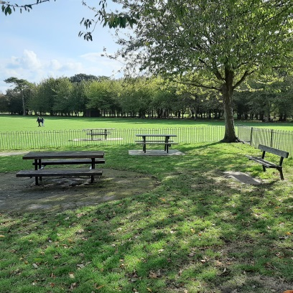

Toilets
There are public toilets, located approximately 100 metres from the play area. There is not a disabled toilet.

