Find Out if Hampden Park Children’s Play Area is accessible for you

Where to find the play area
Hampden Park is located in the Hampden Park area, with public transport stopping within approximately 300m on Decoy Drive. The accessible entrances to the play area are on Hampden Park Drive, Eastbourne BN229QR.

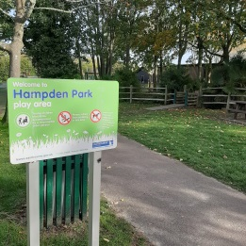

Where to Park
There is ample free parking directly outside the play area and beyond. There are no disabled parking bays.

Getting from the car park to the children’s play area
To get to the play area from main entrance, you can follow a short tarmac surface path which leads the play equipment.

Getting into the children’s play area
There is signage at the two accessible entrances into the play area, with the openings measuring in excess of 1000mm wide. The gates are bright yellow in colour and are opened by hand. The area is accessible to service dogs.

Getting around the children’s play area
The playground surface is accessible and made up of sunken rubber matting, wet pour as well as grass turf and tarmac. It is slightly uneven in places due to differing surface materials.

There is a range of different play apparatus. The play space appeals to most senses, including sight, hearing, touch, providing good bright colour contrast, and a vast selection of equipment providing lots of textures, sounds and patterns.

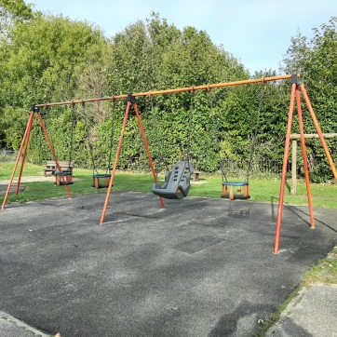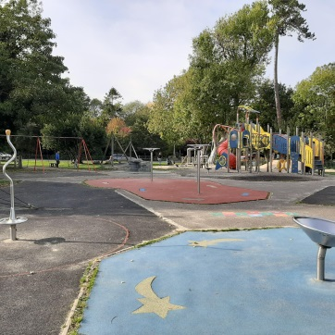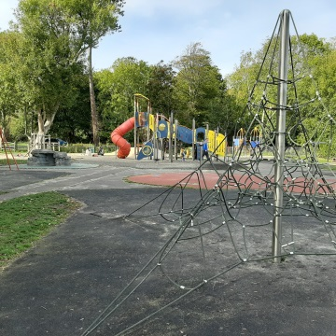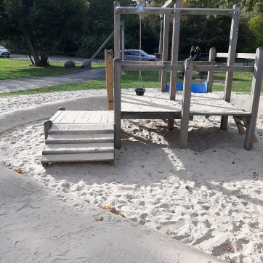

Seating
There are two picnic tables and two benches located in the play area. The tables do not provide back or arm rests. Two of the benches provide arm rests to each end.

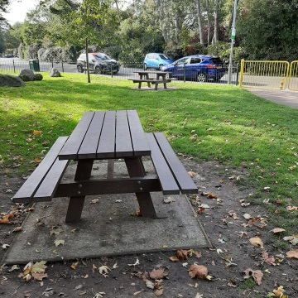

Toilets
There is a disabled toilet and public toilets, located approximately 40 metres from the play area next to the Lakeside Cafe.

