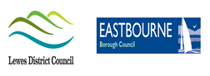  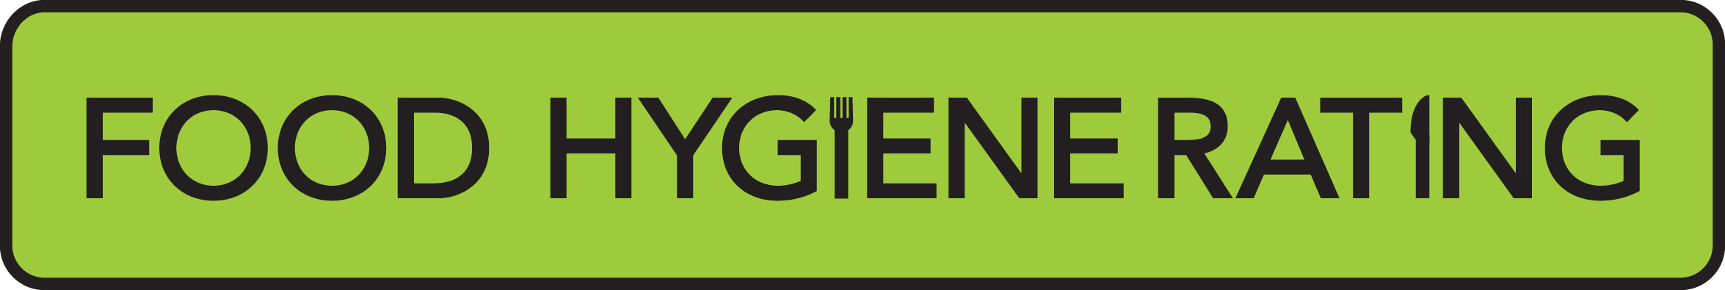  Food Hygiene Rating Scheme:  Appeal form | 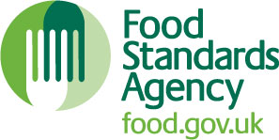

Notes for businesses:

- As the food business operator of the establishment you have a right to appeal the food hygiene rating given following your inspection if you do not agree that the rating reflects the hygiene standards and management controls found at the time of the inspection.
- You have 21 days (including weekends and bank holidays) from the date of receipt of the notification letter to lodge an appeal.
- Please use the form below and return it to the Lead Officer for Food via email or post using the contact details at the bottom of this form.
- The Lead Officer for Food will review your rating and communicate the outcome of your appeal to you within twenty one days.

Business details
Food business operator/proprietor

Business name

Business addresses

Business tel. number |  | Business email

Inspection details
Date of inspection |  |  |  |  | Food hygiene rating given
Date notified of rating

Appeal
I do not agree with the food hygiene rating given by the food safety officer because (please explain below under each of the three headings).

Compliance with food hygiene and safety procedures

Compliance with structural requirements

Confidence in management/control procedures

Signature
Name in capitals

Position |  | Date

Please NOW return this form to Ehealth.ldc@lewes-eastbourne.gov.uk or post to
Lewes District Council – Southover House, Southover Road, Lewes, BN7 1AB
Eastbourne Borough Council – 1 Grove Road, Eastbourne, BN21 4TW

