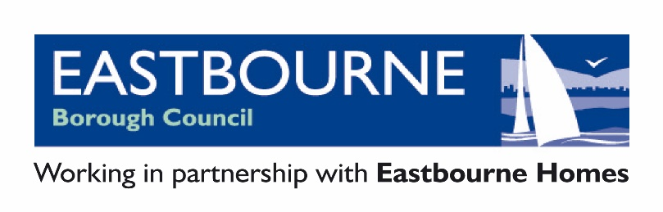

COMPLAINT FORM

- Your Details

Please provide us with your name and contact details.

Title:
First Name:
Last Name:
Address:
Daytime Telephone:
Evening Telephone:
Mobile Telephone:
Email Address:

Your address and contact details will not usually be released unless necessary or to deal with your complaint.

However, we will tell the following people that you have made this complaint:

- the Councillor(s) you are complaining about

- the Monitoring Officer of the authority

We will tell them your name and give them a summary of your complaint. We will give them full details of your complaint where necessary or appropriate to be able to deal
with it. If you have serious concerns about your name or details of your complaint being released to the Member about whom it relates, please complete Section 5 of this form.

Please tell us which complainant type best describes you:

Member of the public
An elected or co-opted member of an authority
An independent person of Eastbourne Borough Council
Member of Parliament
Local Authority Monitoring Officer
Other council officer or authority employee
Other (please specify)

- Making Your Complaint

Please provide us with the name of the Councillor(s) you believe have breached the Code of Conduct and the name of their authority:

Title | First Name | Last Name | Council or Authority Name

- Date of Complaint

Please inform us of any relevant dates concerning your complaints (e.g. when the incident occurred, any relevant meetings dates etc).

- Please explain in this section (or on separate sheets) what the Councillor has done that you believe breaches the Code of Conduct.

If you are complaining about more than one Councillor you should clearly explain what each individual person has done that you believe breaches the Code of Conduct.

It is important that you provide all the information you wish to have taken into account by the Monitoring Officer when it decides whether to take any action on your complaint. For example:

- You should be specific, wherever possible, about exactly what you are alleging the Councillor said or did. For instance, instead of writing that the Councillor insulted you, you should state what it was they said.

- You should provide the dates of the alleged incidents wherever possible. If you cannot provide exact dates it is important to give a general timeframe.

- You should confirm whether there are any witnesses to the alleged conduct and provide their names and contact details if possible.

- You should provide any relevant background information.

Please provide us with the details of your complaint. Continue on a separate sheet if there is not enough space on this form.

- Only complete this next section if you are requesting that your identity is kept confidential.

In the interests of fairness and natural justice, we believe that councillors who are complained about have a right to know who has made the complaint. We also believe they have a right to be provided with a summary of the complaint. We are unlikely to withhold your identity or the details of your complaint unless you have good reason to believe that:-

  - You have reasonable grounds for believing that you will be at risk of physical harm if your identity is disclosed.

  - You are an officer who works closely with the subject councillor and you are afraid of the consequences to your employment or of losing your job if your identity is discovered.

  - You suffer from a serious health condition and there are medical risks associated with your identity being disclosed. In these circumstances the Audit and Governance Committee may request medical evidence of your condition.

Please note that requests for confidentiality or requests for suppression of complaint details will not automatically be granted. The Monitoring Officer will consider the request alongside the substance of your complaint. We will then contact you with the decision. If your request for confidentiality is not granted, we will usually allow you the option of withdrawing your complaint.

However, it is important to understand that in certain exceptional circumstances where the matter complained about is very serious, we can proceed with an investigation or other action and disclose your name even if you have expressly asked us not to.

Please provide us with details of why you believe we should withhold your name and/or the details of your complaint:

- Additional Help

Complaints must be submitted in writing. This includes electronic submissions. However, in line with the requirements of the Equality Act 2010, we can make reasonable adjustments to assist you if you have a disability that prevents you from making your complaint in writing.

We can also help if English is not your first language.

- Declaration

I believe that the facts stated in this complaint form are true.

Signed*…………………………………………………………….

Date…………………………………………………………………

*If you are submitting this form by email and do not have a digital signature, please just type your name.

If you need any support in completing this form, please let me know as soon as possible.

This information can be made available in large print, on audio tape or disk, or in another language upon request. Contact us on 01273 471600 or email committees@lewes-eastbourne.gov.uk

Please return your form to:

The Monitoring Officer
Eastbourne Borough Council
Town Hall
Grove Road
Eastbourne
BN21 4UG

Email complaints marked for the attention of “The Monitoring Officer” can be sent to committees@lewes-eastbourne.gov.uk

